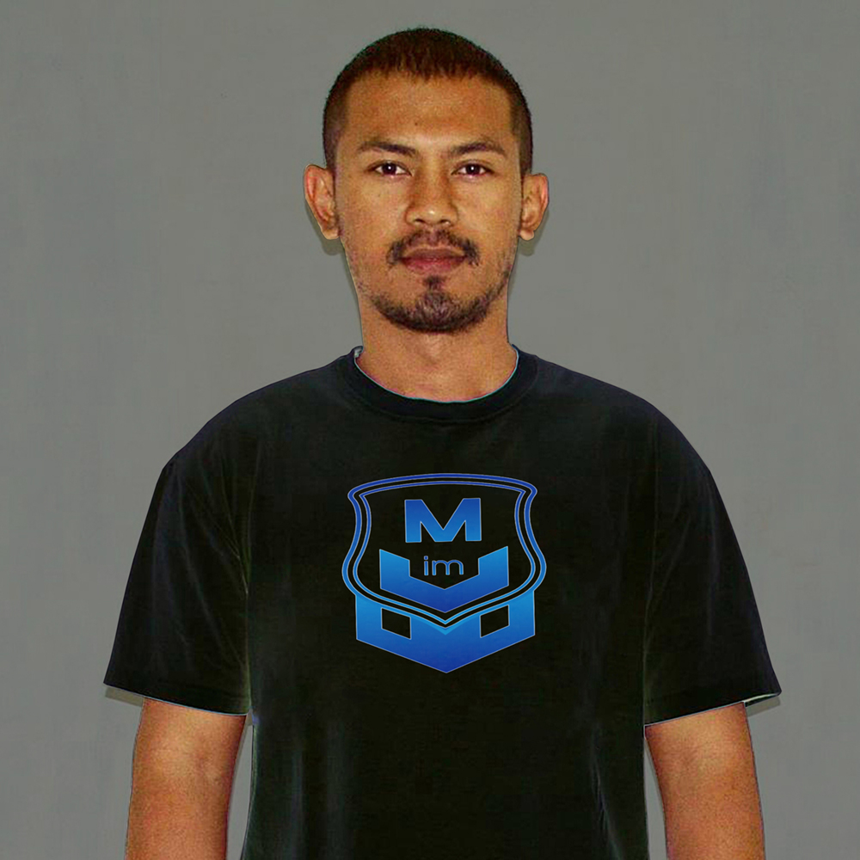

Front End Developer
PROFILE
Name : Mardian Suherman
Phone : +62 856 5946 7422
Email : mardian.2507@gmail.com
Web : https://mardianmoz.web.app
SUMMARY
I'm an enthusiastic and detail oriented Frontend Software Engineer seeking an entry-level position with Company to use my skills in coding, fast learner, good problem solving, good time management, good teamwork and analytical skills.
WORK EXPERIENCE
PT. Nusantara Agung Raya Consultant. (NARCON) - Bandung, Indonesia
Operator GIS (September 2019 - present)
- Prepare GIS work program.
- Coordination in determining the references used with job directors.
- Examines field data and helps perform data analysis in drawing.
- Attend discussion and measurement assistance.
- Responsible for the results of topographic work.
- Map making.
- Follow conservation staff to the field to check conditions in the field compared to conditions seen from satellite imagery.
- Collaborate with the conservation team in collecting GPS data related to program needs.
PT. Indomarco Prismatama - Bekasi, Indonesia
Pramuniaga – Merchandiser (November 2012 - March 2013)
- Checking the products on display.
- Set sales layout.
- Analyze market trends for products.
- Execute promotion strategy.
- Check product stock.

EDUCATION

Politeknik Geologi & Pertambangan AGP Bandung (2014 – 2019)

D3 of Geological Engineering - GPA 3.17

CERTIFICATIONS

- Coding Boot Camp.

SKILLS

- HTML
- CSS
- JavaScript
- Visual Studio Code
- Adobe Photoshop

- Vue.JS
- Bootstrap
- Versioning Control System (Git)
- Drone Pilot
- Photography

LANGUAGES

- Indonesian.
- English.

